## horizontal line



**Crit 2**

**Project Type: Game**

**Unnamed Project**

26 September 2022

Total Hours To Date: 96 Hours

-----------------------------------------------------------------------------------------------------------------------------------

Nhlanhla Langa [Lead Character Designer + Programmer] (2119331)

Luyolo Mbatha [Lead Asset Designer + UI/UX Designer] (1874467)

## Overview

The intended project is a 3D world-building self-study application that allows the user to create both indoor and outdoor environments. Within both the indoor and outdoor categories the player will be afforded several customisations that include changing the look of environmental assets, choosing where some assets will be placed and customising your character model. The application will be facilitated through the *Unity* game engine while using Blender to create the majority of the customisations. This project will consist of a two-person team of Nhlanhla and Luyolo.

## Brainstorming

The intention to develop a world-building application stems from the desire of both members to not only explore and develop our skillset as 3D artists but to further combine the skills we intend to learn with those we are much more familiar with. Both members intended to explore aspects of sculpting within Blender. With this in mind, both members wanted the project to afford them the time to adjust to the indefinite learning curve of sculpting. This is precisely why both members opted for the development of a world-building application that focuses on customisation, as opposed to a physics-based game. The customisation system within the application is intended to create a demand for a variety of 3D assets, which will be challenging, but we believe the application in terms of scripting will be less demand, which in theory will afford both members to spend more time sculpting or modelling.

## Challenges

* We had problems finalising the art style and aesthetics for the project.
* We realised the difficulty of project management.
  + To make things easier for ourselves, we are using Github for source control and Google Drive to share documents that we can both work on at the same time. For asset creation, we’re alternating between Github and Google Drive. We’re still searching for a better software we can use for ease of comparing models
* It has been a long time since we worked with 3D assets and their implementation in video games. We have had to relearn how retopology works and keep our triangles low. We remembered older lessons on baking maps which have proved useful. We’re going to create assets that are both low-poly and high-poly with the intention to bake maps
* This is not a challenge as yet but we are anticipating a challenge in texturing since we do not have much experience in that field

**Current challenge**

Animating character to act according to the user’s actions

Initially, we wanted to set up the to-do list into three categories Work, break and rest category and the in-app there was a set of animations that the character would do within each category, this was difficult as the designers could not possibly know which order the user will complete their tasks in

**Solution**

We have opted to have three action buttons in-app that fall under the same categories as before –Work, break and rest– and the user will have the option of having the player mimic their activities

## **Rubric Of Goals**

| **Goal (Nhlanhla Langa)** | **Description** | **Weight** | **Grade** |
| --- | --- | --- | --- |
| Minimum of three character body types & features | Create blend shapes to have a variation of body sizes, eye shapes, hair | 20% |  |
| Understand texturing, UV unwrapping, retopology and base modelling | Ensure that the model is optimised for video games. The character’s poly count should not be costly to the system. High poly and low poly characters should be made so baking can be possible i.e normal maps, ambient occlusions, UV maps and texture maps | 10% |  |
| Game-ready animations, acceptable rigging practices and poses | Ensuring that the rigged character has been weight painted, the animations created can be exported and are broken down or split into their own NLA clips (NonLinear Animations) to make it easier to implement them inside Unity | 10% |  |
| Implementation of Customisation | Create an easy to use a customisable screen that functions. It should allow players to customise their bodies and the rooms they live in with ease. | 5% |  |
| Implementation of Music Player & UI | Makes it possible to control the music. Perhaps allow applications like Spotify/Youtube Music to log in so users can play music of their choice | 5% |  |
| **Total** |  | 50% |  |

| **Goal (Luyolo Mbatha)** | **Description** | **Weight** | **Grade** |
| --- | --- | --- | --- |
| Minimum of three variations of prop types | Create recognisable styles within each category of props created i.e different architectural styles withing in each prop category. | 20% |  |
| A better understanding of model retopology and texturing | To model and sculpt objects more efficiently to ensure the process of texturing is easier for other artists in the production pipeline. | 10% |  |
| Acceptable rigging practices | Ensuring the rigged objects created for animated objects work pleasantly within Blender and third-party applications i.e Unity. | 5% |  |
| Contextualised Animations | Creating animations that serve to emphasise the theme of the application. An example of this would be the acknowledgement of low-fi music and creating animations that match the mood and tone of the music. | 10% |  |
| Intuitive UI format | Being aware of common UI formats and practices, to create a seamless interface that is easy to under by new users. | 5% |  |
| **Total** |  | 50% |  |

| **Goal (Project)** | **Description** | **Weight** | **Grade** |
| --- | --- | --- | --- |
| Portfolio-Worthy | We want this project to showcase all the hard work, lack of sleep and endless hours of cursing, smiling and torture. We want to show the world, mostly friends, peers and family, that it was worth it!  The project should demonstrate our progress as game design and animation students ready to be employed | 25% |  |
| A playable demo/build | The game should be playable from other Windows devices. It should be industry ready. There shouldn’t be a disconnect between art assets, music, the choice in lighting and game view framing  It should contain the Main Menu, Splash Screen and main game scenes with transitions and audio cues ready. | 25% |  |
| **Total** |  | 50% |  |

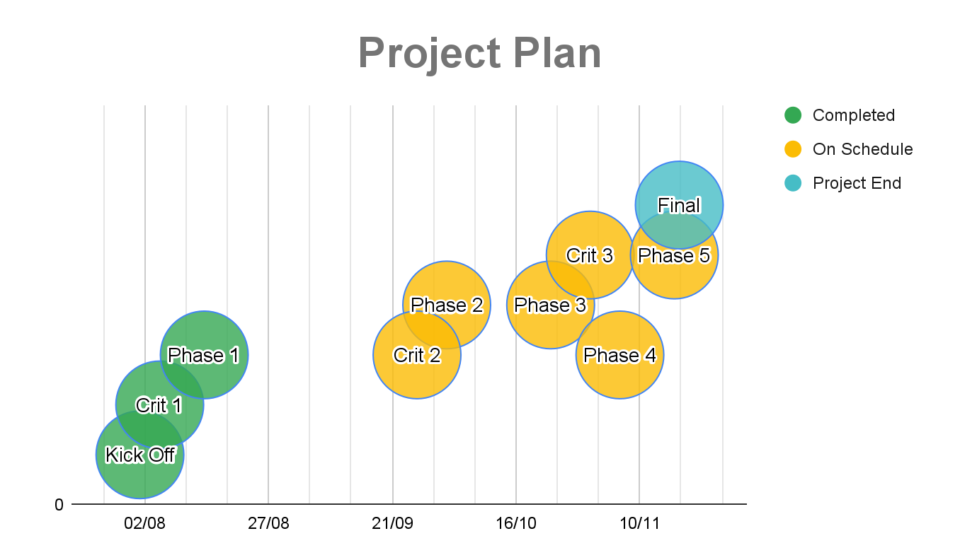

As it stands the outlined length of the project is from 1st August to 5th November–the end date is subject to change. With regards to work structure, the group intends to meet three times a week (**Monday, Thursday and Saturday**). For each meeting, we plan to keep a record of what we did that day and the hours worked. We plan to work for 6 hrs when we meet and keep a schedule similar to the working class of 8 am - 5 pm in hopes to meet our 800 hrs quota. Sunday is our day off.

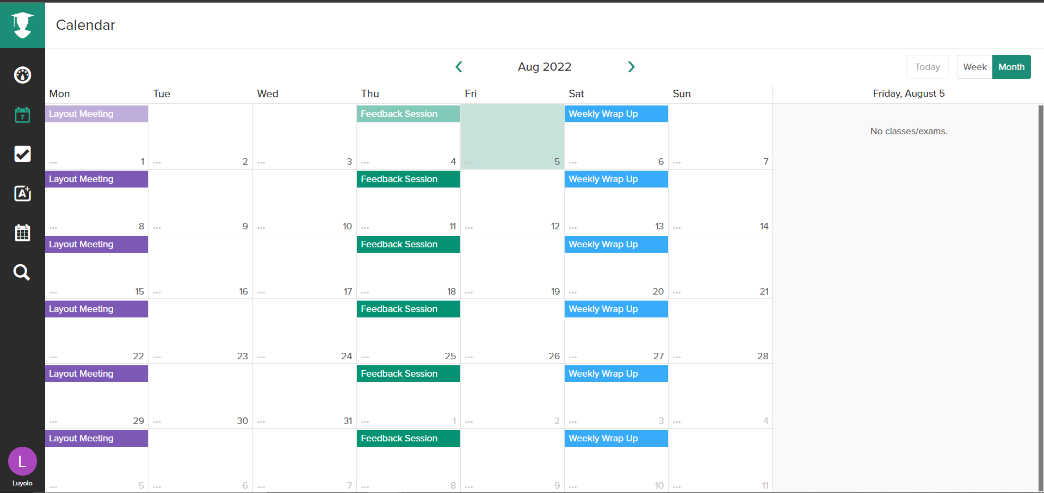

***Figure 1*** Image showing conceptual meeting schedule

Figure 1 shows the group’s outlined meeting schedule. Layout meetings are scheduled for Mondays and discuss the intended goals/ micro-milestones that are to be reached for the week. These meetings are the longest in the schedule as they accommodate for times when it is assumed the members will be working together simultaneously. Feedback sessions are scheduled for Thursdays and are intended to determine the progress made since the layout meeting, discuss any issues faced and the possible rescheduling of specific goals. The weekly wrap-up is scheduled for Saturdays when all the goals are intended to be completed, this was aimed at giving the members an extra day to meet any outlined goals that haven’t yet been achieved

## Skills Need

As stated previously the project seeks to make use of a customisation system. This system would allow the user to customise indoor/outdoor environments, the weather and characters, including clothing, hair types and skin tones. A significant aspect of this system would require dedication to creating 3D objects, the skills favoured to deliver this aspect of the application are modelling and sculpting, with the software chosen to create the assets being Blender. We plan to use the software PureRef which will aid in combining photographic references that will provide an understanding of how games like Fortnite, Two Point Campus/Hospital and Supergiant’s Bastion not excluding films by Pixar/Disney as well as a film we recently watched named *The Sea Beast* achieved their stylised feel and look. This will be especially useful when creating a base for our character model and texturing all the props, especially the ones that need to emit a visual aid like writing on the screen of a laptop.

As the group is also working with unity, it was outlined that there needs to be a level of familiarity with scripting, specifically for UX and UI, beyond this is the understanding of communication design. Below we have listed the skills required:

* 3D Modelling
* 3D Texturing
* 3D Animation
* Asset Optimisation
* C# Programming
* UI/UX Design
* Communication Design
* Music/Audio
* Project Management

## Theme

The primary goal was to create an environment that would allow players to customise and then live in that world. At the moment, our main theme is self-study. We want players to be able to use our application to study. They can set timers and a to-do list that will keep them in check outside of customising their worlds. We want it to be an environment that they choose and want.

## Rationale

Both members believe this project to be one of the more significant projects in our degree, this is because it is one of the last projects of the degree, furthermore, the requirements of the project are open and encourage exploration. This was encouraging for both members as there are a set of skills outside of the university space that we had planned to develop, however academic schedules would often make this difficult, however, the open structure of this project allows both members to align the desired skills with the current project. It is important to mention that it has been possible to align a set of skills that are intended to be developed with previous projects, however, the time allocated to this project has allowed the members to confidently explore an unfamiliar skill to develop, whilst also allowing room for mistakes. Both members have aligned the deliverables of this project with a set of skills they believe are pivotal in the occupations they aim to pursue.

References

<https://github.com/JoshLmao/Spotify4Unity> by JoshLmao licensed under MIT

<https://assetstore.unity.com/packages/tools/integration/s4u-automatic-spotify-integration-129028#description>

<https://assetstore.unity.com/packages/2d/textures-materials/sky/customizable-skybox-174576#content>

‘LeanTween’ by Dented Pixel licensed under UNITY Standard EULA from [LeanTween](https://assetstore.unity.com/packages/tools/animation/leantween-3595)